**SCIT**

|  |  |  |
| --- | --- | --- |
| **Project Requirement Documentation** | | |
| **Version 3.0** | | |
| **27/04/2022** | | |
| **Group:** | **FYP-22-S2-29P** | |
| **Student Name** | **UOW Student ID** | **Email** |
| Chong Hui Wen | 7311436 | hwchong002@mymail.sim.edu.sg |
| Chen Jingguo | 7311709 | jchen120@mymail.sim.edu.sg |
| Ho Bing Yuan | 7224278 | byho001@mymail.sim.edu.sg |
| Viswanadham Udaya Chitanya Krishna | 7083270 | viswanad004@mymail.sim.edu.sg |
| Wong Teck Yong | 7061560 | tywong007@mymail.sim.edu.sg |
|  | **Supervisor** | Premarajan |
|  | **Assessor** | Dr Loo Poh Kok |

**School of Computing and Information Technology Faculty of Engineering & Information Science  
  
  
CSIT321 – Project  
Project Topic: Trip Aid based on LOLs**

**Document Version Record**

|  |  |  |  |
| --- | --- | --- | --- |
| **Version** | **Date** | **Description** | **Author** |
| 1.0 | 13/04/2022 | Initial Draft | Huiwen  Jingguo  Teck Yong |
| 2.0 | 17/04/2022 | 2nd draft | Huiwen  Jingguo  Teck Yong  Bing Yuan  Krishna |
|  |  |  |  |

**1.** **Introduction** 5

1.1 Executive Summary 5

1.2 Project Scope 5

1.3 Project Description 5

1.4 Target Audience 6

**2.** **Research Finding Analysis** 7

2.1 Product Comparison 7

2.1.1 **Visit Singapore** 7

2.1.2 **Tripadvisor** 9

2.1.3 **Visit A City** 10

2.1.4 **Klook** 11

2.1.5 **KKday** 13

2.1.6 **GetYourGuide** 15

**2.2 Comparison of Similar Platforms** 17

**2.3 Rationale Table** 21

**3.** **Project Motivation** 24

4. Functional Requirements 25

4.1 Functional Hierarchy 25

4.2 Use Case Diagram 26

4.2.1 User 26

4.2.2 Admin 27

4.3 Use Case Description 28

**5.** **Proposed Plan** 51

5.1 Execution Strategy 51

5.2 Software Development Method 51

5.2.1 Waterfall Model 51

5.2.2 Agile 53

5.3 Risk Analysis 56

5.4 Project Schedule 57

**6.** **Roles and Responsibilities** 62

**7.** **Development Tools** 63

7.1 Flutter 63

7.2 Firebase 64

7.3 Others 65

**8.** **Expected Results** 66

**9.** **Conclusion** 66

References 67

# **Introduction**

## 1.1 Executive Summary

This proposal describes briefly with regards to a project in which a native application in iOS and Android will be developed for travellers exploring Singapore. In this document, Introduction gives an overview of the project, Project Description provides more details and insights such as the objective and background of the project, along with the expected development methods, breakdown of the roles and responsibilities for the team involved and a scheduled timeline through the entire project phase.

## 1.2 Project Scope

This proposal will discuss a project in developing a native iOS and Android application, to enhance the user experience for travellers navigating around Singapore, by providing elevated functionalities on top of existing travel apps, recommending curated walking routes, recommending interesting sights and written guides all in one nifty app. The project consists of research on the various travel applications in the market, exploring the functionalities the applications have that makes it compelling for the users, areas which can be improved on and implementing those new functions that will attract more users.

## 1.3 Project Description

Travelling and exploring new places has been a favourite pastime of many people. Before the widespread use of the internet and technology, many people referred to travel guides on TVs and guidebooks to check on the recommended places to visit in a country.

With the widespread use of technology, there has been an increase in the number of user-generated content, blogs, videos and information about various places of interest around the world. These user-generated contents allow users to read the different reviews of the places from people around the world. Many people have since then researched their itinerary and even booked flight tickets online.

With the aim of our project being to develop a mobile application as an encyclopaedia about Singapore and its landmarks, we want our users to be able to readily access information and reviews at the touch of their fingertips, aiding them in the planning of their next trip to Singapore.

## 1.4 Target Audience

The key stakeholders of SGTours are mainly tourists who are keen or planning to visit Singapore for their next trip, or for tourists who are already in Singapore and plan to explore Singapore. The public, such as the locals or anyone who is living in Singapore and is keen to tour and explore Singapore beyond the usual retail therapy.

# **Research Finding Analysis**

## 2.1 Product Comparison

### 2.1.1 **Visit Singapore**

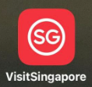

An app designed specifically for tourists in Singapore to navigate and plan their itinerary. Allows travellers to locate places of interest on the go, create and customize your day-to-day itinerary, get information on travel essentials and be updated on recent events and happenings.

**Functionalities:**

* Account: Personal profile creation, customizable profile picture and account details
* My Trip: Save place-of-interest and create itinerary
* Discover: Popular place-of-interest shown based on category
* Search: Ability to search for relevant content within application
* Review System: Review and rating by users in certain posts
* Money Changers: Display money changers available in Singapore
* Map: Display distance require from user’s current location to point-of-interest
* Useful Contacts: Shows the tourist hotline, police hotline, ambulance & fire brigade hotline and embassy contacts
* Handy Tips: Additional tips for travellers to read for smoother transition in Singapore
* Guides: Concentrates on certain area of interest in Singapore
* What’s Near You: Display services located nearby user’s current location
* Social Sharing: Able to share itinerary saved by user in PDF format
* Offline Viewing: Itinerary in downloadable PDF format allows viewing of itinerary without the need of internet connectivity

### 2.1.2 **Tripadvisor**



An American online travel company’s mobile application that offers online hotel reservations and bookings for transportation, lodging, travel experiences, and restaurants.

**Functionalities:**

* Account: Personal profile creation, customizable profile picture and account details
* Plan: Save place-of-interest and create itinerary, invite others to view itinerary
* Explore: Suggestions by application of place-of-interest
* Search: Dedicated search tab to search for relevant content within application
* Review & Rating System: Review and rating by users in certain posts
* Viewing Of Other Users: Ability to view other user’s profile and their reviews, with options to follow or message user
* Forum: Users can post and reply for discussion on relevant topic
* FAQ: Q&A section in the post itself, where users can post queries and other users can answer
* Map: Shows the location of the place-of-interest in the map view
* Nearby: Display services located nearby user’s current location
* Booking Of Interest: Allows user to book certain place-of-interest via the application itself
* Currency Changer: Users may view restaurants in different kind of currencies
* Unit measurements: Interchangeable between Kilometres and Miles
* Social Sharing: Able to share place-of-interest to other social platforms

### 2.1.3 **Visit A City**



Visit A City offers users adjustable guides to allow them to have the flexibility to plan their itineraries, with a wide range of popular sights, tours, and attractions.

**Functionalities:**

* Account: Personal profile creation
* Plan: Recommends standard/fixed itinerary in certain places
* Search: Search bar to look for a destination
* Wishlist: User can save certain posts
* Review & Rating System: Review and rating by users
* Map: Shows the location of the place-of-interest in the map view
* Navigation: Uses Apple Maps/Google Maps/Waze to guide user to place-of-interest
* Nearby: Display services located nearby user’s current location
* Booking Of Interest: Allows user to book certain place-of-interest via the application itself
* Currency Changer: Able to change currency to desired ones within the post itself
* Social Sharing: Able to share place-of-interest to other social platforms
* Offline Viewing: Downloadable content for no internet connectivity viewing
* Contact Us: Feedbacks to application owner available via redirection to their website

### 2.1.4 **Klook**



World-leading travel activities and services booking platform with more than 60,000 activities across 250 major destinations, Klook aims to provide travellers a seamless way to discover and book popular attractions, local tours, rail passes, food options, airport transfers, and unique experiences around the world.

**Functionalities:**

* Account: Personal profile creation, customizable profile picture and account details
* Search: Search bar to look for a destination/place-of-interest
* Wishes: User can save certain posts
* Review & Rating System: Review and rating by users
* Map: Shows the location of the place-of-interest in the map view
* Navigation: Uses Apple Maps/Google Maps to guide user to place-of-interest
* Booking Of Interest: Allows user to book certain place-of-interest via the application itself
* Currency Changer: Able to change currency to desired ones for the entire application
* Social Sharing: Able to share place-of-interest to other social platforms
* FAQ: FAQ of posts and application available
* Filters: Filter/sort posts according to user’s preference
* Payment Method: Multiple payment options to choose from
* Shopping Cart: Add multiple destination to cart before checking out

### 2.1.5 **KKday**

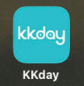

A travel e-commerce platform where people can get their travel needs. All you have to do is to pick a destination and plan the journey with KKday’s variable selections. Over 30,000+ experiences and travel essentials all in one application, KKday.

**Functionalities:**

* Account: Personal profile creation, customizable profile picture and account details
* Search: Search bar and tab to look for a destination
* Wishlist: User can save certain posts
* Review & Rating System: Review and rating by users
* Map: Shows the location of the place-of-interest in the map view
* Navigation: Uses Apple Maps/Google Maps/Waze to guide user to place-of-interest
* Booking Of Interest: Allows user to book certain place-of-interest via the application itself
* Currency Changer: Able to change currency to desired ones for the entire application
* Social Sharing: Able to share place-of-interest to other social platforms
* Filters: Filter/sort posts according to user’s preference
* Chatbot: Post have a chatbot for user to enquire with
* Payment Method: Multiple payment options to choose from
* Feedback: Option to feedback to application developer

### 

### 2.1.6 **GetYourGuide**



GetYourGuide offers users to easily find and book top rated tours, activities and excursions with 24/7 customer service to assure users when booking their tickets.

**Functionalities:**

* Account: Personal profile creation, customizable account details
* Discover: User can see recommended destinations
* Search: Search bar to look for a destination
* Wishlist: User can save certain posts
* Review & Rating System: Review and rating by users
* Map: Shows the location of the place-of-interest in the map view
* Navigation: Uses Apple Maps/Google Maps/Waze to guide user to place-of-interest
* Nearby: Search for destination and sort by distance to see nearby interest
* Booking Of Interest: Allows user to book certain place-of-interest via the application itself
* Currency Changer: Able to change currency to desired ones for the entire application
* Social Sharing: Able to share place-of-interest to other social platforms
* Filters: Filter/sort posts according to user’s preference
* Feedback: Option to feedback to application developer
* Live Chat: User can chat with customer service at any time of the day
* Application Appearance: User can choose dark or light theme

## **2.2 Comparison of Similar Platforms**

|  |  |  |  |  |  |  |  |
| --- | --- | --- | --- | --- | --- | --- | --- |
| Functions | VisitSingapore | Tripadvisor | Visit A City | Klook | Kkday | GetYourGuide | SGTours |
| Android & iOS compatible | Yes | Yes | Yes | Yes | Yes | Yes | Yes |
| Creation of Account/Personal Profile | Yes | Yes | Yes | Yes | Yes | Yes | Yes |
| Update Profile | Yes | Yes | Yes | Yes | Yes | Yes | Yes |
| Viewing of other user's profile and review | No | Yes | No | No | No | No | Yes |
| Social Media Sharing | Yes, sharing of plan/itinerary only | Yes, sharing of posts | Yes, sharing of posts | Yes, sharing of posts | Yes, sharing of posts | Yes | Yes |
| Manage Comment in Forum | No | Yes | No | No | No | No | Yes |
| Add Rating and Review | No | Yes | No | No | No | No | Yes |
| Nearby me | Yes | Yes | Yes | No | No | Yes, sort by distance | Yes |
| Booking of interest directly from application | No | Yes (certain places) | Yes | Yes | Yes | Yes | No |
| Save location of interest | Yes | Yes | Yes | Yes | Yes | Yes | Yes |
| Search tab/bar to find anything | Yes | Yes | Yes | Yes | Yes | Yes | Yes |
| Currency converter | Yes | No | No | No | No | No | Yes |
| Change currency of posts | No, no prices stated on posts | Yes, change currency of entire app | Yes | Yes, change currency of entire app | Yes | Yes, change currency of entire app | No |
| Change unit measurements | No | Yes, Kilometres/Miles | No | No | No | No | No |
| Offline viewing | No | No | Yes | No | No | No | Yes |
| Trip itinerary | Yes | Yes, can invite people to view itinerary | Yes | Yes | Yes, Orders | Yes | Yes |
| Submit Feedback | Yes | Yes | Yes, Contact Us | No | Yes | Yes | Yes |
| Report vulnerability | Yes | No | No | No | No | No | No |
| Chatbot/Live Chat | No | No | No | No | Yes | Yes | No |
| Local Emergency Services System | Yes, Useful Contacts | No | No | No | No | No | Yes |
| Map that shows location of interest | Yes | Yes | Yes | No | Yes | Yes | Yes |
| Navigation Map | Yes | No | Yes, certain posts only | No | Yes | Yes | Yes |
| Sort filters by relevant/date/popularity/price | No | Yes | No | Yes | Yes | Yes | Yes |
| Dark/Light mode | No | No | No | No | No | Yes | No |
| Verification Badge | No | No | No | No | No | No | Yes |

## **2.3 Rationale Table**

|  |  |  |
| --- | --- | --- |
| **Functions** | **To Implement?** | **Rationale** |
| Android & iOS compatible | Yes | * Outreach to more users due to availability in both operating systems |
| Creation of Account/Personal Profile | Yes | * Uniquely identified users in SGTours |
| Update Profile | Yes | * To update their profile details after creation |
| Viewing of other user’s profile and review | Yes | * Allow users to check the reliability of other user’s reviews or to see what else other users have reviewed |
| Social Media Sharing | Yes | * Convenience sharing to other social platforms for users * Free advertisement for SGTours |
| Manage Comment in Forum | Yes | * A place for users to hold discussion * Sharing of experience with other users * Users may possibly find their answers to their query through the forum |
| Add Rating and Review | Yes | * Able to give feedback to the interest based on experience, with satisfactory level from user * Sharing of experience with other users |
| Nearby Me | Yes | * Shows what services/places-of-interest are nearby user’s current location |
| Save location of interest | Yes | * Users can revisit the place-of-interest without the need to search again |
| Search tab/bar to find anything | Yes | * User can find place-of-interest quickly without going through a series of categories |
| Currency converter | Yes | * User can find out how their own currencies will fare when exchanged with foreign currencies without the need of another application |
| Offline Viewing | Yes | * Allows user to download offline viewing for maps, guides, and places-of-interest before not having any internet access when coming to Singapore * If users are in places with weak/no internet access (MRT underground, etc), users will still be able to view |
| Trip itinerary | Yes | * Helps user to plan how they travel from different places-of-interest and manage their time |
| Submit Feedback | Yes | * Developers can know what function or features to improve on based on users experience with SGTours * Receive reports of bug |
| Local Emergency Services System | Yes | * By tapping on the phone number, the user will be redirected to the dial page with the phone number entered. |
| Map that shows location of interest | Yes | * Without the need to search up on the location in another application, users will know location of interest via the map in SGTours |
| Navigation Map | Yes | * Allow users to navigate their way from their location to their desired places-of-interest |
| Sort filters by relevant/date/popularity | Yes | * Different views that user can view their results in |
| Verification Badge | Yes | * Trusted/Reliable users that other users can very likely take reference with |
| Booking of interest directly from application | No | * To redirect users to their official website so that we don’t have to keep update any new deals/promotion * Booking queries will be answered via their official websites |
| Change currency of posts | No | * Posts will not have price indicated since SGTours are redirecting purchases to official merchant website |
| Change unit measurements | No | * Unit measurements should not be an issue for most users as Singapore adopts the International System of Units |
| Report vulnerability | No | * Can be done via submitting feedback |
| Dark/Light mode | No | * Potentially ruining the application theme/UI |
| Chatbot/Live Chat | No | * Application will include an FAQ page * Any other question can be asked through forum |

# **Project Motivation**

Currently, there are various travel mobile applications that provide basic functionalities in guiding tourists/locals around Singapore. As such, with many options available in the markets, users might often find themselves unsure on which app to use or having to reference two or even more applications for a more accurate representation and certain functionalities. This takes up a lot of time and effort and can be very frustrating often as different applications might recommend different choices.

As such, SGTours hopes to be the top choice of users with all such functionalities integrated in an application that will prioritise and recommend users to the best of their preferences, navigating them to their destination with a pleasant user experience and even providing additional functionalities to make it more compelling.

# Functional Requirements

## 4.1 Functional Hierarchy

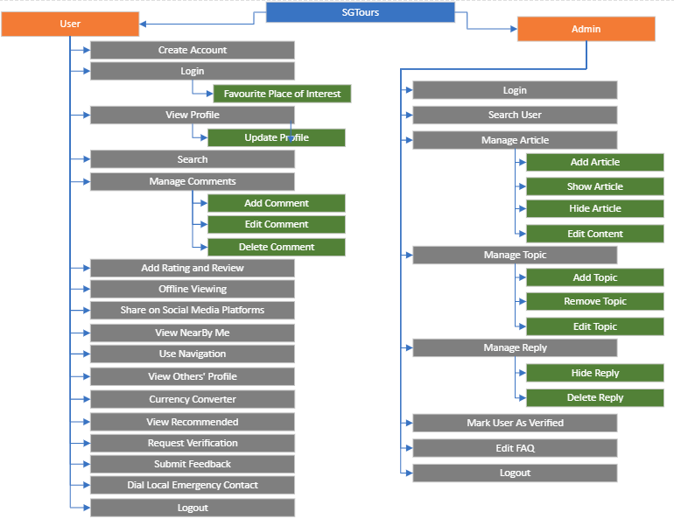

## 4.2 Use Case Diagram

### 4.2.1 User

### 4.2.2 Admin

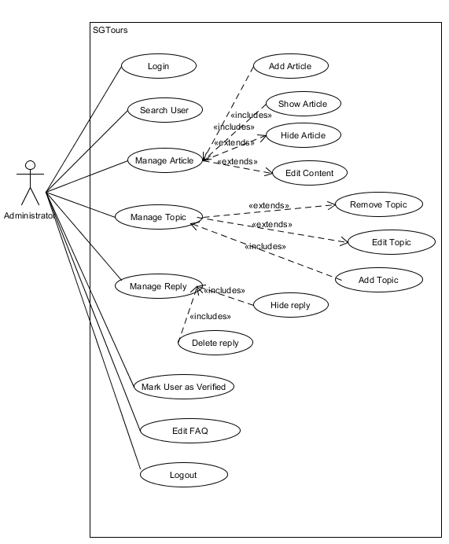

## 4.3 Use Case Description

|  |  |
| --- | --- |
| **Name:** **Create account** | **ID: #001** |
| **Stakeholders and Goals:** User - Want to create an account | |
| **Description:** A user wants to create an account | |
| **Actors:** User | |
| **Trigger:** Users click on “Register” button | |
| **Normal Flow:**   1. User will enter their username, password, and email. 2. Application will check if account is registered before against database records. 3. Application will check if account. 4. Application will register an account based on given username and password. 5. Application will display “Account successfully registered”. 6. End. | |
| **Sub-Flows:** None | |
| **Alternative/Exceptional Flows:**  2a. Application will display “Username/email already registered” If Username/email has already been used.  2b. Application will display “Invalid email” if user enters an invalid email address to register.  2c. Application will display an error message according to password validation. | |

|  |  |
| --- | --- |
| **Name:** **Login** | **ID: #002** |
| **Stakeholders and Goals:** User, Administrator - Existing users registered can login successfully | |
| **Description:** User can access the application features after they login with their user credentials at Login page | |
| **Trigger:** User clicks on “Login” button | |
| **Normal Flow:**   1. Application will prompt user for their registered username and password 2. User enters the details and clicks the login button. 3. Application will check if account records exist against database records 4. Application verifies the user information and allows the user into the application 5. User will be greeted with the home page of the application. 6. End. | |
| **Sub-Flows:**  2a. User clicks the forgot password button and gets the verification message sent to their email for the activation of the new password to Login. | |
| **Alternative/Exceptional Flows:**  3a. Application will prompt user to enter the correct username and passwords in case of any spelling mistakes or incorrect password. | |

|  |  |
| --- | --- |
| **Name:** **View Profile** | **ID: #003** |
| **Stakeholders and Goals:** Use**r -** Users are able to successfully view all the details in their profile | |
| **Description:** Users are able to access or update their profile details and other features which includes their credentials, logout button, settings etc... | |
| **Trigger:** User clicks on the ‘Profile’ button. | |
| **Normal Flow:**   1. User will click on the profile button. 2. Application will display the profile page with all the available settings and features. 3. User can access the profile and check his information by clicking user details. 4. Application will display all the details of the user like username, email address, phone no, age, gender etc... 5. End. | |
| **Sub-Flows:**  4a. When a user clicks on phone number or any other detail, user can edit that information and click ok to update that information. | |
| **Alternative/Exceptional Flows:** None | |

|  |  |
| --- | --- |
| **Name:** **Search** | **ID: #004** |
| **Stakeholders and Goals:** User **-** Users are able to view the details of their search result | |
| **Description:** Users are able to search for attractions in the search bar and the Application will display the list of attractions with the city or the country**.** | |
| **Trigger:** User clicks the search bar**.** | |
| **Normal Flow:**   1. User will click on the search button or search bar. 2. Application will display an on-screen keyboard for the user to type in the attraction they like. 3. Users can type in the attraction name and click the search button. 4. Application will search for the attraction and display the search results in a list format with the best recommendation on top. 5. Users can click on a particular result or place and access the information about the palace, navigation, user reviews etc... 6. End. | |
| **Sub-Flows:** None | |
| **Alternative/Exceptional Flows:** None | |

|  |  |
| --- | --- |
| **Name:** **Itinerary Planner** | **ID: #005** |
| **Stakeholders and Goals:** User - Offers user to have a platform to plan their itinerary | |
| **Description:** Offers user to have a platform to plan their itinerary | |
| **Trigger:** User click on “Plan” button | |
| **Normal Flow:**   1. User search for places-of-interest. 2. User clicks on the ‘add’ button to save places-of-interest into the planner platform. 3. User can also remove places-of-interest out from the platform. 4. After user is done, user can save the itinerary for future reference. 5. Done. | |
| **Sub-Flows:**  2a. User deletes the itinerary saved from before by clicking the ‘delete’ button.  2b. User can also edit the itinerary saved from before. | |
| **Alternative/Exceptional Flows:** None | |

|  |  |
| --- | --- |
| **Name:** **Manage Comment** | **ID: #006** |
| **Stakeholders and Goals:** User - Users are able to add and edit their comment | |
| **Description:** Users manage their comment with add and edit comment function to post/modify a comment | |
| **Trigger:** User press the forum button. | |
| **Normal Flow:**   1. User will click the forum section. 2. Application will display the forum section. 3. User can post any query or comment to the discussion. 4. User can also modify their comment by clicking on edit button and modify. 5. End. | |
| **Sub-Flows:**  4a. User can delete the comment they posted. | |
| **Alternative/Exceptional Flows:** None | |

|  |  |
| --- | --- |
| **Name:** **Add Rating and Review** | **ID: #007** |
| **Stakeholders and Goals:** User -Users are able to add rating and review to any tourist location | |
| **Description:** Users can add the rating of an attraction based on their experience. | |
| **Trigger:** User click on a add rating button. | |
| **Normal Flow:**   1. User will search for the point of interest. 2. Application will perform search and display the location. 3. User can click on rating button. 4. Application will show the rating page with 5 stars available to rate. 5. User can add on a review in a textbox in the application. 6. User can rate the location based on their experience. 7. End. | |
| **Sub-Flows:** none | |
| **Alternative/Exceptional Flows:** none | |

|  |  |
| --- | --- |
| **Name:** **Offline Viewing** | **ID: #008** |
| **Stakeholders and Goals:** User -Users are able to use the application offline. | |
| **Description:** Users can view their place of interest even they are offline | |
| **Trigger:** User has no access to data connection to view the application live but wantsto retain information for navigation. | |
| **Normal Flow:**   1. User search for the place of interest. 2. Application will display the location. 3. User can click the place and access all the information offline. 4. End. | |
| **Sub-Flows:** none | |
| **Alternative/Exceptional Flows:** none | |

|  |  |
| --- | --- |
| **Name:** **Share on Social Media platforms** | **ID: #009** |
| **Stakeholders and Goals:** User- Users are able to share their activity on to popular social media platforms | |
| **Description:** Users can share their content and reviews to other social media platforms**.** | |
| **Trigger:** User click on share button. | |
| **Normal Flow:**   1. User selects the place of interest. 2. Application will display the information about the place. 3. User can press the share button to share their review of the place to their favourite social media platform. 4. End. | |
| **Sub-Flows:** none | |
| **Alternative/Exceptional Flows:** none | |

|  |  |
| --- | --- |
| **Name:** **View Nearby Me** | **ID: #010** |
| **Stakeholders and Goals:** User -To view Places-of-Interest near the user | |
| **Description:** To view Places-of-Interest near the user | |
| **Trigger:** Users click on “View Nearby Me” button | |
| **Normal Flow:**   1. User wants to view places of interest nearby. 2. User grants Location Permission. 3. Application will display Places-of-Interest near the user via geo-tracking. 4. End. | |
| **Sub-Flows:** None | |
| **Alternative/Exceptional Flows:**  3a. Application not showing any Places-Of-Interest due to Location Permission not granted | |

|  |  |
| --- | --- |
| **Name:** **Use Navigation** | **ID: #011** |
| **Stakeholders and Goals:** User - Users are able to use maps for navigation to their place of interest | |
| **Description:** Use Navigation | |
| **Trigger:** User clicks on ‘directions’ button. | |
| **Normal Flow:**   1. User will search for the tourist place they want to know about. 2. Application will display the place result. 3. User can click the place in order to show a full page view. 4. User will click on the ‘directions’ button. 5. Application will use maps to navigate the user with directions information from their current location. 6. End | |
| **Sub-Flows:** none | |
| **Alternative/Exceptional Flows:**  5a. Application not showing directions due to Location Permission not granted | |

|  |  |
| --- | --- |
| **Name:** **View Other User’s Profile** | **ID: #012** |
| **Stakeholders and Goals:** User - To view other user’s profile | |
| **Description:** To view other user’s profile | |
| **Trigger:** User search for other user’s profile | |
| **Normal Flow:**   1. User enters user’s username. 2. Application checks against database records for user . 3. Application will display the user’s profile based on the trigger. 4. Users click on other user’s profile 5. User will be able to view user’s profile information and check if they are verified. 6. User will also be able to view their reviews and rating. 7. End. | |
| **Sub-Flows:** None | |
| **Alternative/Exceptional Flows**:  3a. User does not exist thus Application is unable to display requested User’s Profile. | |

|  |  |
| --- | --- |
| **Name:** **View Recommended** | **ID: #013** |
| **Stakeholders and Goals:** User - To view recommended Places-of-Interest | |
| **Description:** To view recommended Places-of-Interest | |
| **Trigger:** Users click on “View Recommended” button | |
| **Normal Flow:**   1. User wants to get recommendations on places to visit 2. User clicks on “View Recommended” button 3. Application will display recommended Places-of-Interest 4. End. | |
| **Sub-Flows:** None | |
| **Alternative/Exceptional Flows:**  1a**.** Registered User can add the place of interest to their favourites for easier viewing in the future. | |

|  |  |
| --- | --- |
| **Name:** **Request Verification** | **ID: #014** |
| **Stakeholders and Goals:** User - To request for verification for their account | |
| **Description:** To request for verification for their account | |
| **Trigger:** Users click on “Request Verification” button | |
| **Normal Flow:**   1. User is a local influencer/Local Opinion Leader and wants to get verified. 2. User submits a form and request for verification. 3. User waits for administrator to approve their verification. 4. Administrator will review and approve/reject 5. If approved, application will add a verification badge on user’s account 6. End. | |
| **Sub-Flows:**  5a. Application will notify users that their verification request has been rejected | |
| **Alternative/Exceptional Flows:** None | |

|  |  |
| --- | --- |
| **Name: Submit Feedback** | **ID: #015** |
| **Stakeholders and Goals:** User - To leave feedback for developers | |
| **Description:** Allow user to leave feedback for improvement or any bugs that user encounter, so that developers can improve on the application to bring a better experience to the user | |
| **Trigger:**  User click on “Submit A Feedback” button | |
| **Normal Flow:**   1. User encounters an issue or has a suggestion regarding the application 2. User locates the “Submit Feedback” Page 3. User key in their email address and the feedback into the feedback box and fills in the necessary details. 4. User hit the “Submit” button 5. End. | |
| **Sub-Flows:** None | |
| **Alternative/Exceptional Flows:** None | |

|  |  |
| --- | --- |
| **Name:** **Dial Local Emergency Contact** | **ID: #016** |
| **Stakeholders and Goals:** User -To contact Singapore Police, Fire Brigade or Ambulance | |
| **Description:** Allow user to quickly contact emergency agencies without the need of knowing Singapore’s emergency contact | |
| **Trigger:** User click on “Emergency Contact” | |
| **Normal Flow:**   1. User click on “Call Police” or “Call Fire Brigade/Ambulance” button. 2. Redirects to device’s phone dial pad with number keyed in. 3. User calls the number in the dial pad. 4. Done. | |
| **Sub-Flows:** None | |
| **Alternative/Exceptional Flows:** None | |

|  |  |
| --- | --- |
| **Name:** **Currency Converter** | **ID: #017** |
| **Stakeholders and Goals:** User - To convert SGD to other foreign currency and vice versa | |
| **Description:** To have a simple currency converter function that allow foreigners to know how their own currencies will fare when exchanged with SGD | |
| **Trigger:** User clicks on ‘Currency Converter’ Button | |
| **Normal Flow:**   1. User will select which country they want their currency to be converted. 2. User will be shown 2 textboxes (Left: SGD, Right: Selected country). 3. User can enter an amount in left textbox, right textbox will show converted currency (and vice versa). 4. End. | |
| **Sub-Flows:** None | |
| **Alternative/Exceptional Flows:**  3a. User did not enter decimal/integer value, converted currency will not be displayed | |

|  |  |
| --- | --- |
| **Name:** **Logout** | **ID: #018** |
| **Stakeholders and Goals:** User, Administrator - User/ Administrator able to successfully logout of the Application | |
| **Description:** Users are able to end the current session and logout of the application | |
| **Trigger:** User/ Administrator clicks on “Logout” button | |
| **Normal Flow:**   1. User/ Administrator will go to account details page by clicking the profile button 2. Application will display the profile page with all the available options along with a logout button. 3. User/ Administrator will press the logout button. 4. Application will end the session and return to login page 5. End | |
| **Sub-Flows:** None | |
| **Alternative/Exceptional Flows:** None | |

|  |  |
| --- | --- |
| **Name:** **Search User** | **ID: #019** |
| **Stakeholders and Goals:** Administrator - Administrator can search for user and view their profil**e** | |
| **Description:** Administrator can search for user and view their profile | |
| **Trigger:**   1. Administrator should be logged in. 2. Administrator should be on the “Search User” page. | |
| **Normal Flow:**   1. Administrator will enter the user’s ID in the search field. 2. Administrator clicks on the “Search” button. 3. Application displays the user matching the value in the search field. 4. Administrator selects on the search result. 5. Application displays a popup of the user’s profile information. 6. End. | |
| **Sub-Flows:** None | |
| **Alternative/Exceptional Flows:**  2a. Administrator is not able to find any matching result  2b. Application will display a “No Matching User Found” error message | |

|  |  |
| --- | --- |
| **Name**: Add Article | **ID: #020** |
| **Stakeholders and Goals:** Administrator -Administrator to publish articles on the application | |
| **Description:** Administrator can publish articles for users to view on the application. | |
| **Trigger:** When the administrator clicks on the ‘Add New Article’ button | |
| **Normal Flow:**   1. Administrator will select on the “Add New Article” button. 2. Application will display the “Article Draft” page for user to edit. 3. Administrator to enter the title and content of the article. 4. Administrator selects on the “Publish Article” button. 5. Application will publish and display the article on the application page. 6. End. | |
| **Sub-Flows:**  2a. Administrator select on “Cancel” button when editing the article.  2b. Application will display a “Do you want to cancel editing the article” popup  2c. Administrator select on the “Yes” button | |
| **Alternative/Exceptional Flows:** None | |

|  |  |
| --- | --- |
| **Name:** **Show Article** | **ID: #021** |
| **Stakeholders and Goals:** Administrator - Administrators will update the visibility of the article so that it will be displayed in the application. | |
| **Description:** Administrator updates the visibility of the article so that it will be displayed to users in the application. | |
| **Trigger:**   1. Administrator should be logged in. 2. Visibility of the article to be displayed should be set to hidden. | |
| **Normal Flow:**   1. Administrator will select on a article that is in the “hidden” state. 2. Application will display the article and its content. 3. Administrator checks on the visibility checkbox to ensure that the article is displayed. 4. Administrator clicks on “Save” button to update the status of the article. 5. Application will display the article to users. 6. End. | |
| **Sub-Flows:** None | |
| **Alternative/Exceptional Flows:** None | |

|  |  |
| --- | --- |
| **Name:** **Hide Article** | **ID: #022** |
| **Stakeholders and Goals:** Administrator -Administrators will update the visibility of the article so that it will be hidden in the application. | |
| **Description:** Administrator updates the visibility of the article so that it will be hidden to users in the application. | |
| **Trigger:**   1. Administrator should be logged in 2. Visibility of the article to be displayed should be set to displayed. | |
| **Normal Flow:**   1. Administrator will select on a article that is in the “displayed” state. 2. Application will display the article and its content. 3. Administrator unchecks on the visibility checkbox to ensure that the article is hidden. 4. Administrator clicks on “Save” button to update the status of the article. 5. Application will hide the article to users. 6. End. | |
| **Sub-Flows:** None | |
| **Alternative/Exceptional Flows:** None | |

|  |  |
| --- | --- |
| **Name:** **Edit Content** | **ID: #023** |
| **Stakeholders and Goals:** Administrator - To edit the content of an article posted | |
| **Description:** Administrator can edit article to change content | |
| **Trigger:** When the administrator clicks on the ‘Edit Article’ button | |
| **Normal Flow:**   1. Application will display the “Article Draft” page for user to edit. 2. Administrator will edit content of the article. 3. Administrator selects on the “Update Article” button. 4. Application will update and display the updated article on the application page. | |
| **Sub-Flows:**   1. Administrator selects on “Cancel” button when editing the article. 2. Application will display a “Do you want to cancel editing the article” popup. 3. Administrator selects on the “Yes” button. 4. End. | |
| **Alternative/Exceptional Flows:** None | |

|  |  |
| --- | --- |
| **Name:** **Add Topic** | **ID: #024** |
| **Stakeholders and Goals:** Administrator -Administrator to add new topic into the forum | |
| **Description:** Administrator to add new topic into the forum | |
| **Trigger:** Administrator clicks on “Add new Topic” button | |
| **Normal Flow:**   1. Application will display the “Topic” draft page for the user to edit. 2. Administrator enters title and content of the topic. 3. Administrator selects on “Publish Topic” button. 4. Application will publish and display the topic on the application page. 5. End. | |
| **Sub-Flows:**  2a. Administrator select on “Cancel” button when editing the topic.  2b. Application will display a “Do you want to cancel editing the topic” popup.  2c. Administrator select on the “Yes” button. | |
| **Alternative/Exceptional Flows:**  3a. Administrator publish empty topic.  3b. Application will not publish the empty topic.  3c. Application prompts administrator to enter title and content. | |

|  |  |
| --- | --- |
| **Name:** **Remove Topic** | **ID: #025** |
| **Stakeholders and Goals:** Administrator - Administrator to remove topic from the forum | |
| **Description:** To remove topic from the forum if needed | |
| **Trigger:** Administrator clicks on “Delete Topic” button | |
| **Normal Flow:**   1. Application will show a kebab menu on the forum topic, showing the “Delete Topic” button. 2. After clicking, Application will prompt a pop-up to confirm deletion. 3. Once confirmed, another pop-up will show “Topic deleted”. 4. Application will remove the topic from the forum. 5. End. | |
| **Sub-Flows:** None | |
| **Alternative/Exceptional Flows:** None | |

|  |  |
| --- | --- |
| **Name: Edit Topic** | **ID: #026** |
| **Stakeholders and Goals:** Administrator **-** To edit/modify added topic | |
| **Description:** To allow administrator to edit the content of the topic if needed | |
| **Trigger:** Administrator clicks on “Edit Topic” button | |
| **Normal Flow:**   1. Application will show a kebab menu on the forum topic, showing the “Edit Topic” button. 2. Application will display the “Topic” draft page for the administrator to edit. 3. Administrator selects on “Update Topic” button. 4. Application will update and display the updated topic on the application page. 5. End. | |
| **Sub-Flows:**  2a. Administrator select on “Cancel” button when editing the topic.  2b. Application will display a “Do you want to cancel editing the topic” popup.  2c. Administrator select on the “Yes” button. | |
| **Alternative/Exceptional Flows:**  3a. Administrator publish empty topic.  3b. Application will not publish the empty topic.  3c. Application prompts administrator to enter title and content. | |

|  |  |
| --- | --- |
| **Name:** **Hide Reply** | **ID: #027** |
| **Stakeholders and Goals:** Administrator **-** Administrators will update the visibility of the user’s reply in the forum or in the review section | |
| **Description:** Administrators will update the visibility of the user’s reply in the forum or in the review section | |
| **Trigger:**   1. Administrator should be logged in 2. Administrator should be on the forum/review page | |
| **Normal Flow:**   1. Administrator will select on a user’s reply. 2. Application will display an option pop-up about the actions that can be done to the reply. 3. Administrator selects on the “Hide Reply” button. 4. Application displays a “Hide this reply” popup. 5. Administrator selects “Yes”. 6. Application hides the reply. 7. End. | |
| **Sub-Flows:** None | |
| **Alternative/Exceptional Flows:** None | |

|  |  |
| --- | --- |
| **Name:** **Delete Reply** | **ID: #028** |
| **Stakeholders and Goals:** Administrator **-** Administrators will mark the reply in the forum/review page as deleted | |
| **Description:** Administrators will mark the reply in the forum/review page as deleted | |
| **Trigger:**   1. Administrator should be logged in 2. Administrator should be on the forum/review page | |
| **Normal Flow:**   1. Administrator will select on a user’s reply. 2. Application will display an option pop-up about the actions that can be done to the reply. 3. Administrator selects on the “Delete Reply” button. 4. Application displays a “Delete this reply” popup. 5. Administrator selects “Yes”. 6. Application marks the reply as deleted. 7. End. | |
| **Sub-Flows:** None | |
| **Alternative/Exceptional Flows:** None | |

|  |  |
| --- | --- |
| **Name: Mark User as Verified** | **ID: #029** |
| **Stakeholders and Goals:** Administrator **-** To verify users as Local Opinion Leaders/Influencer | |
| **Description:** To verify users as Local Opinion Leaders/Influencer | |
| **Trigger:** User request for verification of account | |
| **Normal Flow:**   1. Application will display account request for verification. 2. Administrator ensures that the account must represent a real person, registered business or entity. 3. Administrator clicks on “Verify” button. 4. Application will verify the requested account as ‘Verified’. 5. End. | |
| **Sub-Flows:**  2a. Administrator select on “Reject” button.  2b. Application will prompt user for reason of rejection.  2c. Administrator enters reason of rejection.  2d. Application will send a notification to requested account with reason of rejection. | |
| **Alternative/Exceptional Flows:** None | |

|  |  |
| --- | --- |
| **Name:** **Edit FAQ** | **ID: #30** |
| **Stakeholders and Goals:** Administrator **-** To modify/update the FAQ | |
| **Description:** To modify/update the FAQ | |
| **Trigger:** Administrator clicks on “Edit” button | |
| **Normal Flow:**   1. Application will display the “FAQ” draft page for the user to edit. 2. Administrator adds/modifies content of FAQ page. 3. Administrator selects on “Update” button. 4. Application will update and display the updated FAQ on the application page. 5. End. | |
| **Sub-Flows:**  2a. Administrator select on “Cancel” button  2b. Application will display a “Do you want to cancel editing the FAQ” popup  2c. Administrator select on the “Yes” button | |
| **Alternative/Exceptional Flows:** None | |

# **Proposed Plan**

## 5.1 Execution Strategy

After scrutinous research and multiple discussions, the team has agreed to incorporate the Agile SCRUM Development methodologies approach in order to provide and sustain a high responsive approach regarding the deliverables. Details such as description of the methods the team will be applying, proposed timeline and rationale regarding the choice of Agile SCRUM are listed below.

## 5.2 Software Development Method

### 5.2.1 Waterfall Model

The Waterfall model, commonly known as an example of a Sequential model, in which phases are divided and the output of one phase serves as the input of the next phase. The logic behind the model works as each phase must be completed before the next phase can start.

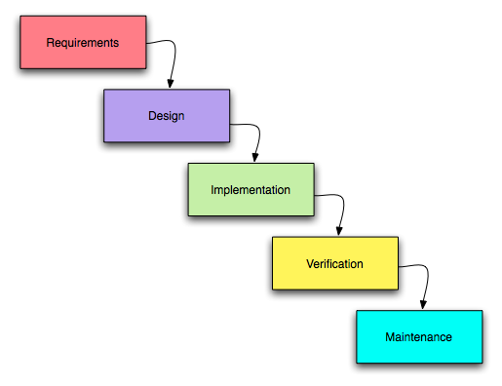

Despite the model being easy to understand and simple, the model is not ideal due to its inflexibility of not allowing changes to be implemented. Moving backwards in a phase is difficult, and the delivery of the final product will only be available towards the end of the cycle because there is no prototype. As such, the risk factor is on the high side. Testing can only be done towards the later stage in the cycle making it difficult to identify and assess the possible challenges and risks. Therefore, with the various disadvantages listed, the team will not be adopting the waterfall model for this project.

### 5.2.2 Agile

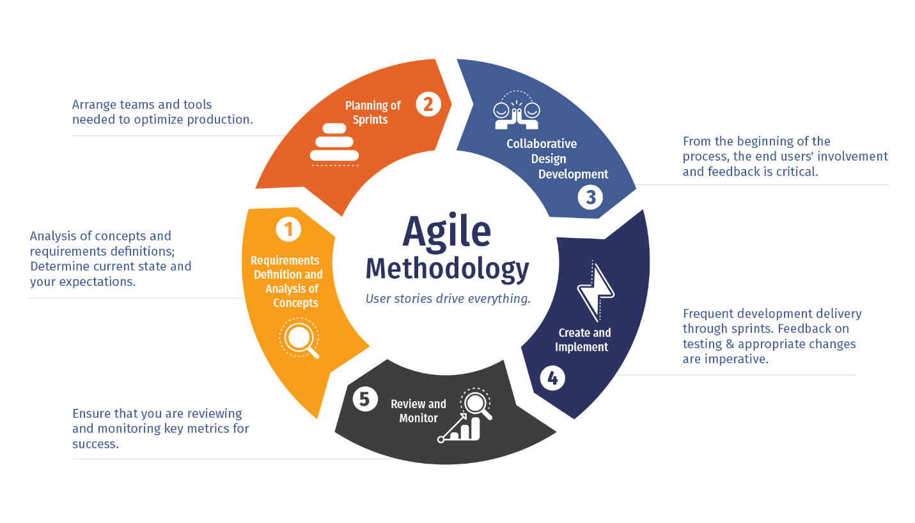

The Agile software methodology was developed to improve upon existing software development processes which were more complex. The aim was to speed up the processes and create a more efficient working model for teams.

The Agile software methodology was founded on four key values. These are:

1. Individuals and interactions over processes and tools

This means that the focus should be on the team, and emphasises that communication plays a key role in developing a product. When more people interact with each other and share their ideas, they build better products.

1. Working software over comprehensive documentation

The agile practices improved on other software development methodology which resulted in teams creating exhaustive documentation with technical specifications and requirements. These documents had to be prepared before developers started to write code, which would delay the software development process. Agile improves on these by streamlining these documents and condense these information into user stories. These stories equip the developer with all the details they need to start working on the software.

1. Customer collaboration over contract negotiation

Agile highlights the importance of customer collaboration. When bringing customers into the development process and getting their opinions and feedback, the development team can gain a deeper understanding of what the user really wants from the application being built.

1. Responding to change over following a plan

Another main difference Agile is from traditional methodologies is that it advocates for change in the software development process. With Agile teams mostly working in short, iterative cycles, it believes that changes in the software development process can lead to better products.

Following the above four values, Agile methodology is said to bring about the following benefits. These are:

1. Satisfied Customers
2. Improved quality
3. Adaptability
4. Predictability
5. Reduced risk
6. Better communication

In the context of our project, we have adopted the Agile Scrum methodology. This is because of the short development time of 2 months that this project has. By working in short, iterative cycles (sprints), we are able to keep track of our progress at the start and end of every sprint. At the start of every sprint, we can identify the tasks that are important and focus on those in the current sprint. This embraces the Agile value of responding to change.

## 5.3 Risk Analysis

|  |  |  |  |  |
| --- | --- | --- | --- | --- |
| **Risk Category** | **Identified Risk** | **Impact** | **Probability Risk** | **Rating** |
| Communication | Communication between the team and stakeholders should be established and maintained at all times. | H | L | M |
| Maintenance | Application should be functional and bug-free. | H | L | M |
| Resources | Application should be compatible on the platforms listed for various stakeholders’ usage. | L | L | L |
| Security | All user information must be stored safely and Application shall not be compromised at all times. | M | M | M |
| Technical | Application unable to achieve project requirements | H | L | M |
| User | Requirements from Stakeholders must be interpreted accurately as to warrant met requirements. | H | L | M |

## 

## 5.4 Project Schedule

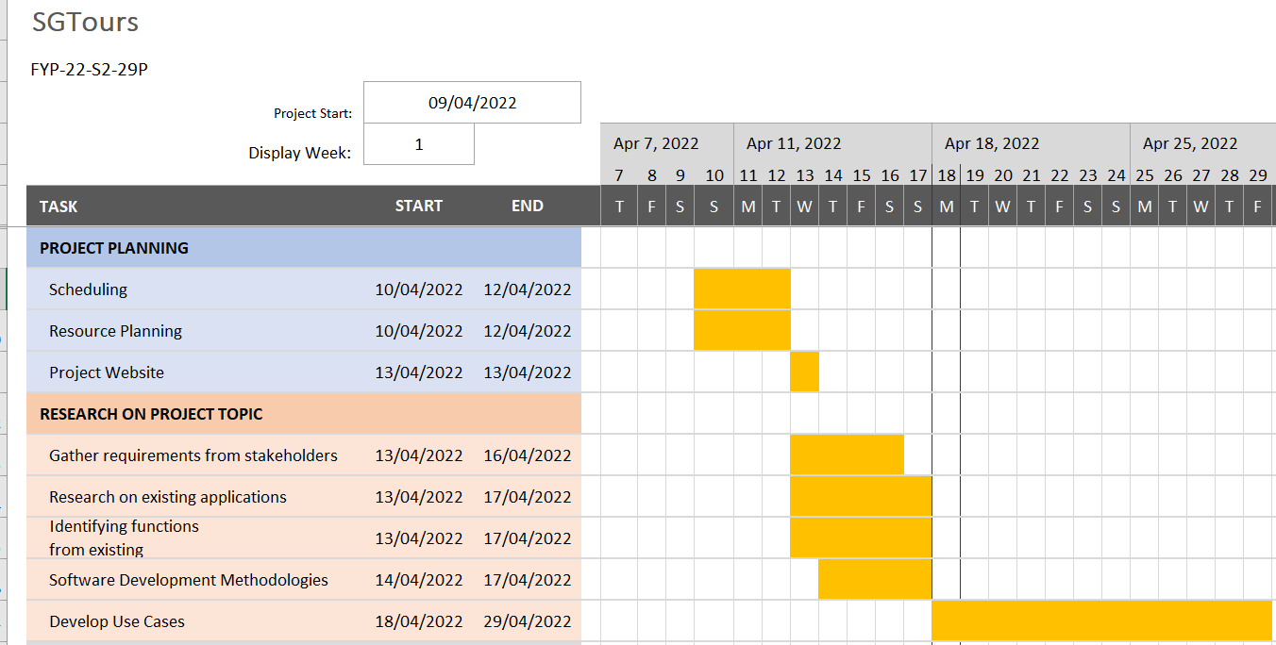

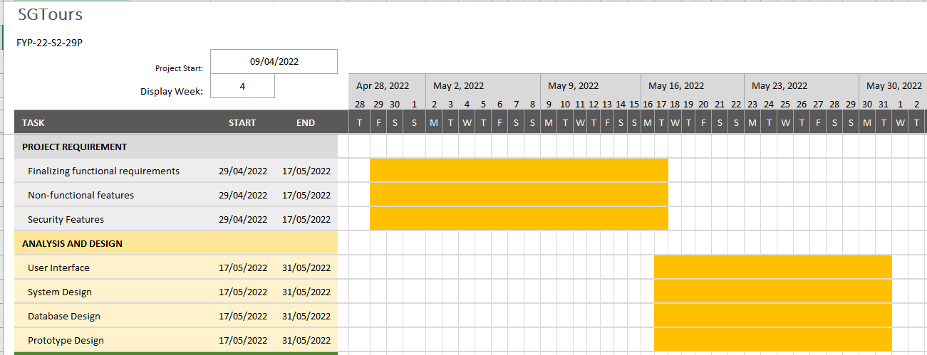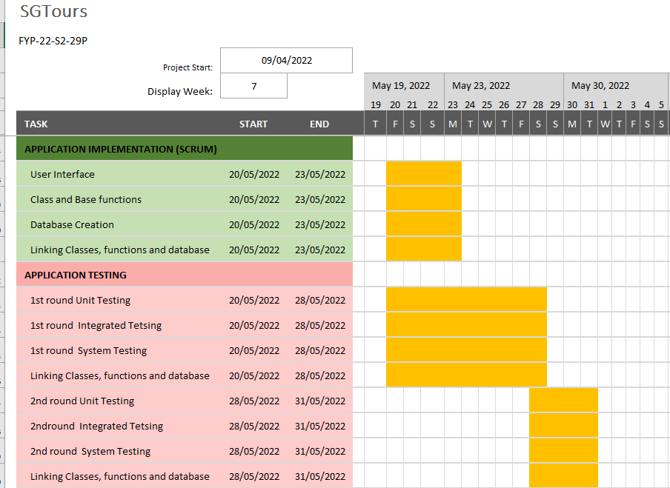

## 

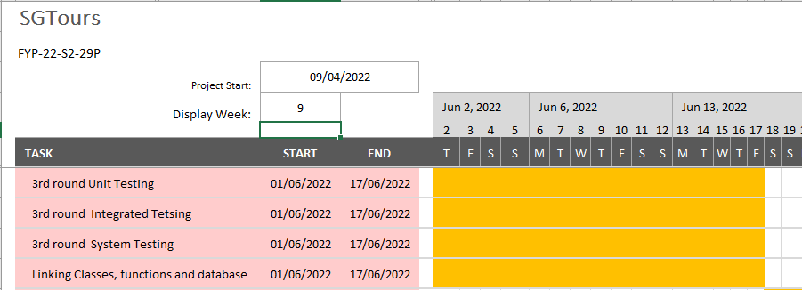

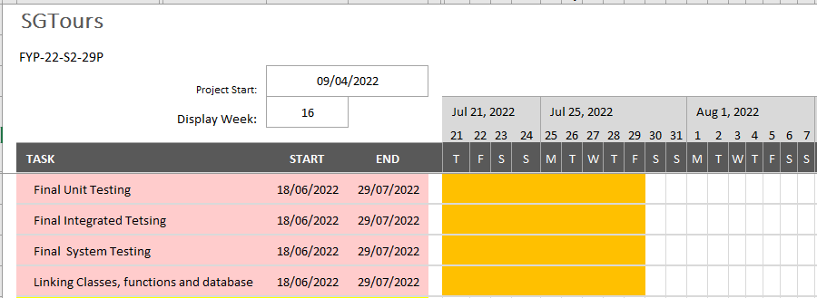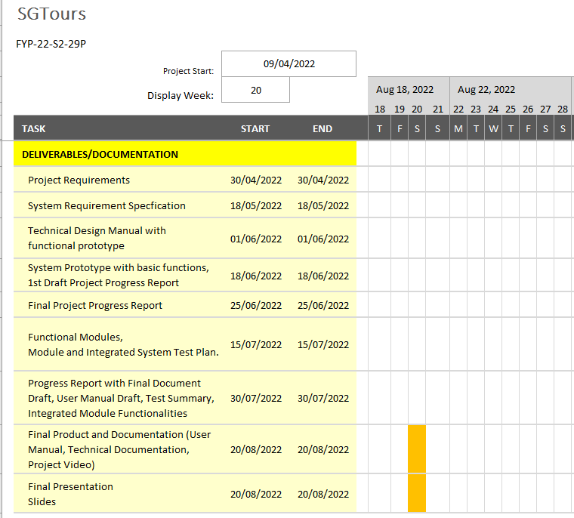

## 

# **Roles and Responsibilities**

|  |  |  |  |  |  |
| --- | --- | --- | --- | --- | --- |
|  | Chong Hui Wen | Chen Jingguo | Ho Bing Yuan | Viswanadham Udaya Chitanya Krishna | Wong Teck Yong |
| Project Manager | ✔ |  |  |  |  |
| System Analyst |  | ✔ |  |  |  |
| UI Designer | ✔ |  |  | ✔ | ✔ |
| Test Designer |  |  | ✔ |  |  |
| Application Tester |  |  | ✔ | ✔ | ✔ |
| Database Designer | ✔ | ✔ |  |  |  |
| Backend Developer | ✔ | ✔ | ✔ | ✔ | ✔ |

# 

# **Development Tools**

## 7.1 Flutter

Flutter is an open-source UI software development kit created by Google.

It is used to develop cross platform applications for Android, iOS, Linux, macOS, Windows, Google Fuchsia, and the web from a single codebase.

**Pros:**

Flutter is easy to use and quick to learn as you can create fully functional apps with significantly less code. Its framework ensures a quick and simple installation that takes around 30 minutes, at which point we can build our first Flutter application.

Flutter uses Dart language, and both Flutter and Dart are open-source, which allow us free access to the original code and all the documentation that we will need. Its documentation is also user-friendly and easy to navigate, making it quick and simple to find answers to our questions.

Flutter has a feature called ‘Hot Reload’, which allows us to make changes to the back-end and observe the front-end changes instantly, decreasing the need to reload the entire application frequently. It would save us valuable development and compilation time.

**Cons:**

As Flutter uses Dart language, we are required to learn it as none of us are familiar with this language. Also, Flutter-built applications are relatively big, which would take up quite some space on IOS/Android devices.

**Programming Language Used:**

Dart Language

As stated in the pros of Flutter, it is easy to use and quick to learn as both Flutter and Dart language are open source. As we want to ensure

We want to ensure that we can create a prototype fast so that we can correct any changes if needed. Hence, choosing Flutter will allow us to save up some time as it is stated in the pros, it is easy to use and quick to learn. At the same time, Flutter and Dart language are open source, which will allow us to search for any solution for any problems we face during the development phase.

## 7.2 Firebase

In order to help developers, build better real-time applications, Google acquired firebase in 2014, a backend development software, that offers a number of services, including, analytics, authentication, cloud messaging, real-time database, crashlytics, performance and test lab.

**Pros:**

* Unlike traditional relational databases, Firebase Realtime Database is a NoSQL database that uses JSON format to store data.
* Changes in data are reflected immediately across all platforms and devices within milliseconds.
* Internal cache that allows offline support
* Integrates well with Flutter.
* Free basic plan

**Cons:**

* Limited querying and indexing
* Uses JSON to store data, not easy to migrate
* Need to pay if hosting huge amount of connection

As projected that SGTours will not require a high level of use, Firebase is a good choice for a database as it is free to use. The ability to reflect new changes in data also allows users of SGTours to get real time updates, which is a huge advantage in today’s technology world. As well as it supports flutter integrations. Thus, the team has concluded to use Firebase Realtime Database as the database for SGTours application.

## 7.3 Others

We made use of UMLet - UML Diagram Editor to facilitate the creation of use case diagrams as it is relatively simple to use and user friendly.

The Team also made use of the Microsoft Office Package for the documentation. For instance, the team made use of Visio in the creation of the functional hierarchy, showcasing the functions proposed for the functional requirements isolated during the research. Excel was used to create the Gantt Chart, providing an overview of the timeline throughout this entire project.

As the team wanted a repository that could monitor changes while collaborating on the same file during the project phase, Github serves as an excellent platform with many resources available. As such, the team will make use of Github to store all relevant documents and the fact that it is open-source makes it easier for the team to work with. Github also allows integration and works with many different languages, along with the fact that it provides documentation, allowing the team to keep track of the changes made so far. As such, the team’s decision to utilise such tool.

# **Expected Results**

At the end of the project, the team hopes to achieve a fully functional application that provides not only seamless integration of maps, not only integrate existing functionalities that tourism applications available in the market contain, but also include functionalities that are refreshing and enticing to the users. The team also hopes to eliminate any frustration that arises while using such said applications.

# **Conclusion**

In conclusion, the team hopes to make a mobile application that will tap on existing resources and add on new functionalities. Convenience and seamless integration is what the team aims to achieve. With the functionalities discussed above in this document, the team is confident that the proposed functionalities will enhance the user experience.

Thank you for your kind consideration.

# References

Djermanović, D., n.d. *Introduction to Firebase Realtime Database.* [Online]   
Available at: https://www.raywenderlich.com/books/saving-data-on-android/v1.0/chapters/12-introduction-to-firebase-realtime-database  
[Accessed 17 April 2022].

DOIT Software ©, 2022. *Flutter vs. Kotlin in 2022: Which Is Best for Cross-Platform App Development?.* [Online]   
Available at: https://doit.software/blog/flutter-vs-kotlin-which-is-best-for-cross-platform-app-development  
[Accessed 18 April 2022].

DOIT Software, 2022. *Flutter vs React Native in 2022: Which One is Better for Your Project?.* [Online]   
Available at: https://doit.software/blog/flutter-vs-react-native  
[Accessed 18 April 2022].

Gaba, I., 2022. *Agile Vs Waterfall: Choosing the Best Methodology.* [Online]   
Available at: https://www.simplilearn.com/tutorials/agile-scrum-tutorial/agile-vs-waterfall  
[Accessed 19 April 2022].

Google LLC, n.d. *Firebase Realtime Database.* [Online]   
Available at: https://firebase.google.com/docs/database  
[Accessed 18 April 2022].

Guriev, B., 2021. *Firebase Pros and Cons: When You Should and Shouldn’t Use Firebase | OSDB.* [Online]   
Available at: https://osdb.io/firebase-pros-and-cons-when-you-should-and-shouldnt-use-firebase-osdb/  
[Accessed 17 April 2022].

Rosencrance, L., n.d. *Google Firebase.* [Online]   
Available at: https://www.techtarget.com/searchmobilecomputing/definition/Google-Firebase  
[Accessed 17 April 2022].

SOFTWARETESTINGHELP 2022, 2022. *What Is SDLC Waterfall Model?.* [Online]   
Available at: https://www.softwaretestinghelp.com/what-is-sdlc-waterfall-model/  
[Accessed 19 April 2022].

Wrike, Inc, n.d. *The Benefits and Advantages of Agile.* [Online]   
Available at: https://www.wrike.com/agile-guide/benefits-of-agile/  
[Accessed 19 April 2022].